**[Opinion](https://www.nytimes.com/section/opinion)**

**Guest Essay**

**The Impossible Math of Philanthropy**

Feb. 3, 2025

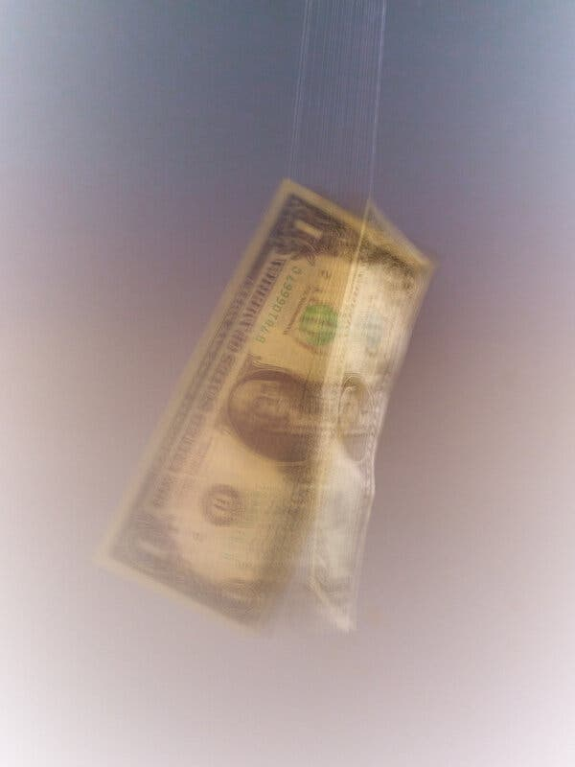

Credit...Philotheus Nisch for The New York Times

**By Hans Taparia and Bruce Buchanan**

Mr. Taparia and Mr. Buchanan are professors at New York University’s Stern School of Business.

The Lower East Side of Manhattan is home to some of the oldest and most storied charities in the country, founded at the dawn of the Progressive era. University Settlement, established in 1886, opened one of the first public baths in New York City. In 1893, Henry Street Settlement began offering health care to neighborhood residents and later convened the conference that led to the formation of the N.A.A.C.P.

Today, New Yorkers in need continue to depend on these charities for housing assistance, child and elder care, food security, education and employment training. Yet poverty on the Lower East Side has been [increasing](https://furmancenter.org/neighborhoods/view/lower-east-side-chinatown#_blank) for decades, and [Manhattan](https://www.socialexplorer.com/blog/post/social-explorer-analysis-for-the-new-york-times-finds-manhattan-income-gap-exceeds-third-world-levels-13279) has the most unequal income distribution of any large county in America.

It’s a similar story across the country. In recent years, Bill Gates, Warren Buffett, Michael Bloomberg and many others have poured billions into fighting poverty, protecting the environment and improving health outcomes. Corporate [giving](https://givingusa.org/5-takeaways-and-next-steps-from-the-giving-usa-2024-report/#:~:text=Corporate%20giving%20is%20a%20small,the%20same%20period%20(5.3%25).) has also grown significantly over the past 5 years.Yet despite these efforts, income inequality is worse than it’s been [since before the Great Depression](https://www.cbpp.org/research/poverty-and-inequality/a-guide-to-statistics-on-historical-trends-in-income-inequality), and poverty and its associated social pathologies remain stubbornly pervasive. What gives?

There’s a simple answer, one you’ll never hear in the grand halls of the charity gala circuit: The math of philanthropy simply doesn’t work. And it never will.

Americans typically understand charities as organizations that pick up where the government leaves off — championing the poor, the environment, the sick and the marginalized. But this framing is incomplete, and frankly misleading.

More often than not, charities work to mitigate harms caused by business. Every year, corporations externalize trillions in costs to society and the planet. Nonprofits form to absorb those costs, but have at their disposal only a tiny portion of the profits that corporations were able to generate by externalizing those costs in the first place.This is what makes charity such a good deal for businesses and their owners: They can earn moral credit for donating a penny to a problem they made a dollar creating.

Take the fast-food industry, where wages are so low that a [majority](https://laborcenter.berkeley.edu/fast-food-poverty-wages-the-public-cost-of-low-wage-jobs-in-the-fast-food-industry/#_blank) of workers’ families are enrolled in public assistance. When an underpaid McDonald’s worker seeks a free meal at a soup kitchen, the soup kitchen is, in effect, stepping in to supplement a legal but inadequate wage. The lower the wage, the greater the profits for McDonald’s, which puts the soup kitchen in the position of indirectly subsidizing those profits.

According to census [data](https://www.census.gov/data/tables/2023/demo/income-poverty/p60-279.html), about half of Americans earn less than [a living wage](https://livingwage.mit.edu/articles/99-a-calculation-of-the-living-wage), which we estimate conservatively at $75,000 for a family of three. For every family to earn a living wage, we estimate that employers would need to pay at least $1.9 trillion more in wages and salaries. But in 2023, only [$77 billion](https://www.nptrust.org/philanthropic-resources/charitable-giving-statistics/) of all American charitable dollars went toward so-called human service organizations such as food banks and homeless shelters. Employers will never choose to make up that difference, because keeping wages low is what fuels so much of the profits their shareholders demand.

Government welfare programs play a much larger role than charity in bridging the $1.9 trillion gap, but they are also insufficient. Total spending on economic security programs by the U.S. government in 2023 [was](https://www.cbpp.org/sites/default/files/4-14-08tax_rev7-18-24.pdf) $545 billion, still a small fraction of what it would take for all Americans to meet their basic needs. If the Trump administration fulfills its plan to slash social services such as food stamps and child care assistance, while diverting more wealth to the rich through tax cuts, the math will get only worse and the pressure on charities will compound.

A similar predicament exists for environmental cleanup.

Think about Coca-Cola, which, up until the 1970s, was sold mostly in refillable glass bottles. In the 1980s and ’90s, it switched to plastic — effectively outsourcing the cost of recycling to municipalities, or, [more accurately](https://www.nytimes.com/2024/06/17/climate/ask-nyt-climate-recycling.html), the cost of plastic pollution to the world.

Last year, researchers identified Coca-Cola as the [single largest branded plastic polluter](https://www.science.org/doi/10.1126/sciadv.adj8275?adobe_mc=MCMID%3D72077797092235851240392577489555653962%7CMCORGID%3D242B6472541199F70A4C98A6%2540AdobeOrg%7CTS%3D1713919364) on the planet. The long-term environmental costs of plastic pollution are enormous — $3.7 trillion per year, according to one [study](https://media.wwf.no/assets/attachments/Plastics-the-cost-to-society-the-environment-and-the-economy-WWF-report.pdf). Based on its [share](https://oceana.org/press-releases/oceana-coca-cola-and-pepsis-plastic-packaging-use-increases-by-hundreds-of-millions-of-pounds/) of plastic production, that means Coca-Cola’s plastic alone inflicts some $30 billion in annual environmental damage. That’s about three times the company’s net income in [2022](https://investors.coca-colacompany.com/filings-reports/all-sec-filings/content/0000021344-23-000011/0000021344-23-000011.pdf). How much did it donate to charitable causes that year? Not quite $95 million, a small share of which went toward recycling programs.

That leaves governments on the hook for the rest of the damage, but here, too, public spending is grossly insufficient, and it is almost certain to become more so under the Trump administration. The total proposed [budget](https://www.epa.gov/planandbudget/budget) for the Environmental Protection Agency in the current fiscal year is less than $11 billion; as of 2018, states and local governments [contributed](https://www.census.gov/library/stories/2021/06/public-spending-on-protecting-environment-up.html) about $32 billion a year to protect natural resources — but again, that’s a tiny fraction of what it would cost to fix the damage corporations inflict on the environment each year.

These calculations reveal why so many good and seemingly well-funded causes fail to move the needle. The health and environmental [costs](https://www.rockefellerfoundation.org/report/true-cost-of-food-measuring-what-matters-to-transform-the-u-s-food-system/) from the food industry exceed the revenue it generates. The [cost](https://www.cdc.gov/nccdphp/divisions-offices/about-the-office-on-smoking-and-health.html#_blank) in the United States of health care from smoking is several times the revenue of the cigarette industry. The costs of mental illness, misinformation and political discord created by the social media industry are immeasurable.

Nonprofits that work to reverse obesity, prevent addiction or treat anxiety will never have anywhere near the resources they need to fully meet their missions.

Advertisement

[SKIP ADVERTISEMENT](https://www.nytimes.com/2025/02/03/opinion/philanthropy-charity-billionaires-math.html?smid=nytcore-ios-share&referringSource=articleShare#after-story-ad-3)

Building a more equitable world would require addressing the damage that for-profit companies cause at the root.As the European Union has shown through a variety of new laws in recent years, regulation can be used to force businesses to internalize their hidden social costs. Alternatively, corporations could be legally rechartered so that their bylaws compel them to put public interests ahead of their shareholders. Both approaches would hurt companies’ profit margins.

For this to work, the public would also need to develop greater skepticism of the rich entrepreneurs who, with more cash than they could ever spend, donate portions of their wealth to favored causes. Lionized for their achievements and revered for their compassion, they bask in their status as society’s saviors. Meanwhile, the corporations they own extract wealth and externalize costs on a scale that dwarfs their largess. With one hand they generate supernormal profits by plundering society, and with the other they dole out a few crumbs to “save the world.” But they never will. The math simply doesn’t work.

**More on philanthropy**